

**Tribhuvan University**

**Faculty of Humanities and Social Science**

**AN INTERNSHIP REPORT**

**ON**

**FULL STACK DEVELOPMENT**

**AT**

**BLAZETHEMES PVT.LTD.**

**Submitted To:** -

Department of Computer Application

Shahid Smarak College

Kirtipur – 10, Kathmandu, Nepal

*In partial fulfillment of the requirements of the Bachelors in Computer Application*

**Submitted by: -**

Amir Maharjan (26202002)

TU Registration no: 6-2-262-3-2020

April 2025

Under the Supervision of

**Mr. Hari Lal Chalise**

# **DECLARATION**

I hereby declare that the Internship Report entitled **“FULL STACK DEVELOPEMENT”** submitted to the Department of Computer Science and Information Technology, Tribhuwan University (TU), is an original report in accordance with the internship for partial fulfillment of the requirements for the degree of Bachelor Degree in Computer Application (BCA), under the guidance of Mr. Hari Lal Chalise of Shahid Smarak College, Kirtipur, Kathmandu, Nepal. This internship report is original and has not been submitted earlier in part or full in this or any other form to any university or institute, here or elsewhere, for the award of any degree.

Amir Maharjan



Tribhuvan University

Faculty of Humanities and Social Science

Shahid Smarak College

# **MENTOR’S RECOMMENDATION**

I hereby recommend that this internship report, prepared under my mentorship by **“Amir Maharjan”** entitled **“Full Stack Development”**, be accepted as fulfilling a partial requirement of the degree of Bachelor in Computer Application (BCA).

-----------------------------

Mr. Bidur Maharjan

**CEO**

Blazethemes Pvt. Ltd.



Tribhuvan University

Faculty of Humanities and Social Science

Shahid Smarak College

# **SUPERVISOR’S RECOMMENDATION**

I hereby recommend that this project prepared under my supervision by **“Amir Maharjan”** in entitled **“Full Stack Development”** partial fulfillment of the requirements for the degree of Bachelor of computer Application (BCA) is recommended for the final evaluation.

-----------------------------

Hari Lal Chalise

**SUPERVISOR**

Shahid Smarak College

Kirtipur, Nayabazar



Tribhuvan University

Faculty of Humanities and Social Science

Shahid Smarak College

# **LETTER OF APPROVAL**

This is to certify that this internship report prepared by **“Amir Maharjan”** entitled **“Full Stack Development”** in partial fulfillment of the requirements for the degree of Bachelor in Computer Application (BCA) has been evaluated. In our opinion it is satisfactory in the scope and quality as a project for the required degree.

|  |  |
| --- | --- |
| -----------------------------  Hari Lal Chalise  **Supervisor**  Shahid Smarak College  Kirtipur, Nayabazar | -----------------------------  Mr. Sanjay Jnawali  **Coordinator**  Shahid Smarak College  Kirtipur, Nayabazar |
| -----------------------------  Internal Examiner | -----------------------------  External Examiner |

# **COMPLETION LETTER**

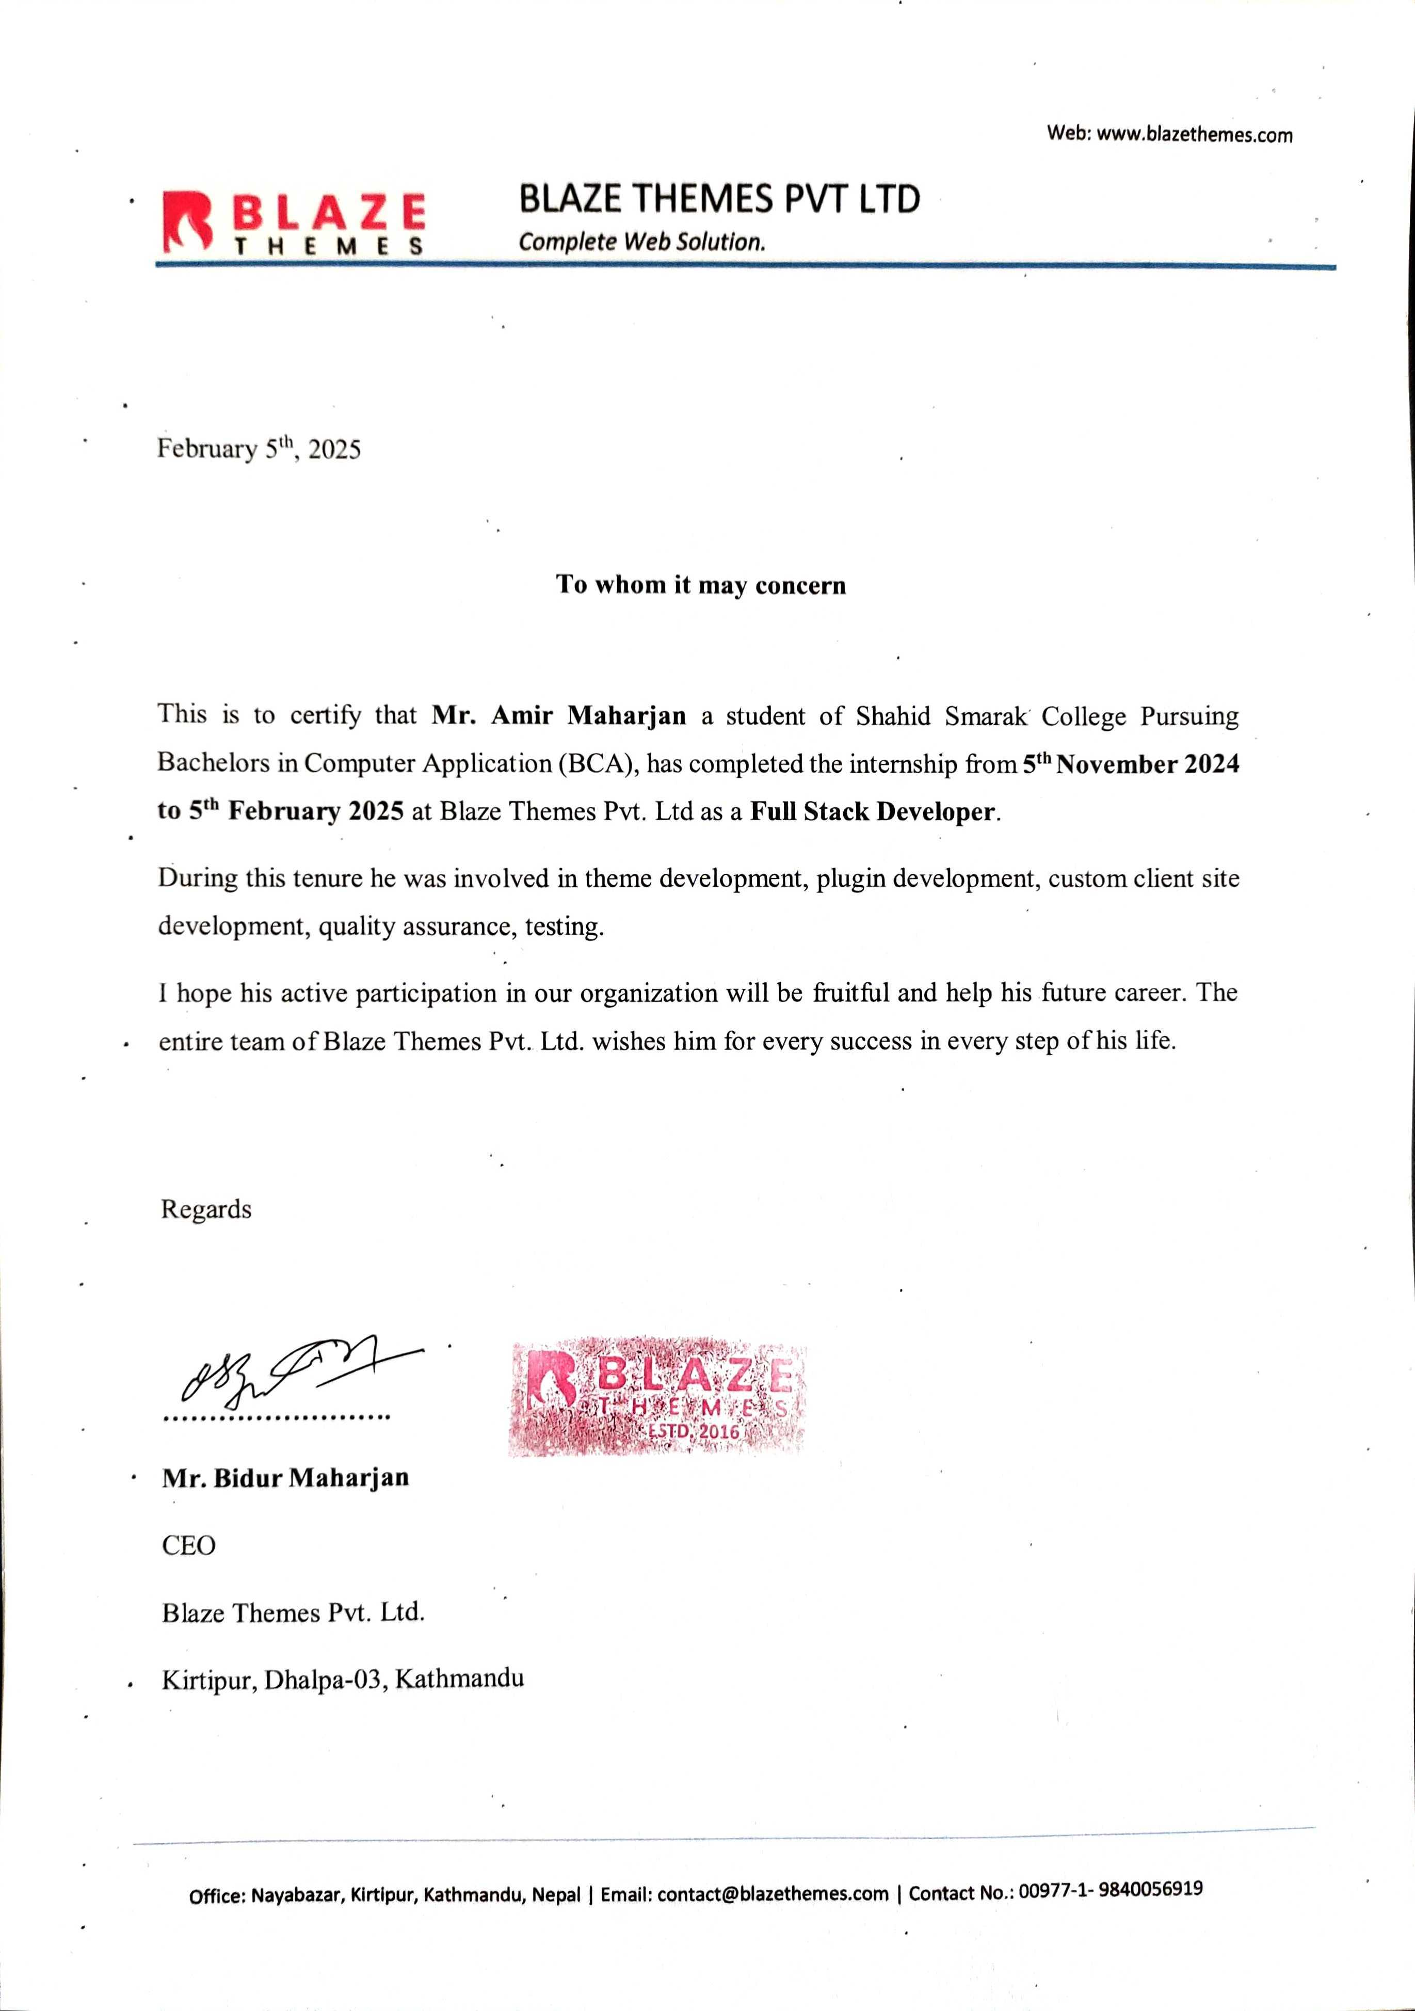

# **ACKNOWLEDGEMENT**

I would like to express my deepest gratitude to all those who have supported and guided me throughout the completion of my internship program.

First and foremost, I am sincerely grateful to my mentor **Mr. Dinesh Maharjan** for his unwavering support, valuable insights and continuous encouragement throughout my internship.

I extend my heartfelt gratitude to the supervisor **Mr. Hari Lal Chalise** who played a pivotal role in the successful completion of my internship. His unwavering support and contributions have been instrumental.

A special thanks to **Blazethemes Pvt. Ltd.** for providing me this opportunity where I could start my professional career. I have gained valuable programming skills, soft skills, etc. due to this opportunity.

Lastly, I would like to thank my family and friends who have supported, encouraged, and motivated me during this time. It is a collaborative effort that my internship program has been completed so smoothly.

Yours Sincerely,

Amir Maharjan

# **ABSTRACT**

This internship at **Full Stack Development**, a renowned web development firm, provided me with a hands-on opportunity to apply my academic knowledge in web development, particularly in WordPress theme and plugin development. My responsibilities included assisting the development team in creating custom WordPress themes and plugins, as well as customizing existing themes to meet client specifications. I contributed to coding front-end features using HTML, CSS, and JavaScript, while also developing back-end functionalities through PHP for WordPress environments. In addition to theme and plugin development, I participated in the testing and optimization of websites for better performance, user experience, and compatibility across devices. Throughout this internship, I gained a solid understanding of the WordPress ecosystem, including its template hierarchy, plugin architecture, and the importance of creating secure and scalable web solutions. Working with the team, I also became proficient in debugging, troubleshooting, and ensuring that projects met the high standards expected by clients. This experience greatly enhanced my technical skills in both front-end and back-end development and provided me with valuable insights into the project management process within a web development company. The internship has strengthened my ability to develop robust and dynamic websites, preparing me for a future career in web development and WordPress development.

***Keywords:*** *Web development, WordPress, Debugging, Front-end, Backend, Themes, Plugins*

**Table of Contents**

**DECLARATION** i

**MENTOR’S RECOMMENDATION** ii

**SUPERVISOR’S RECOMMENDATION** iii

**LETTER OF APPROVAL** iv

**COMPLETION LETTER** v

**ACKNOWLEDGEMENT** vi

**ABSTRACT** vii

**LIST OF FIGURES** x

**LIST OF TABLES** xi

**LIST OF ABBREVIATION** xii

**Chapter 1 Introduction** 1

1.1 Introduction 1

1.2 Problem Statement 1

1.3 Objectives 2

1.4 Scope and Limitation 2

1.5 Report Organization 3

**Chapter 2 : Introduction to Organization** 4

2.1 Organization Details 4

2.2 Organizational Hierarchy 5

2.3 Working Domains of Organization 6

2.4 Description of Intern Department/Unit 7

**Chapter 3 : Background Study and Literature Review** 8

3.1 Background Study 8

3.2 Literature Review 8

**Chapter 4 : Internship Activities** 10

4.1 Roles and Responsibilities 10

4.2 Weekly Log 10

4.3 Description of the projects involved during internship 12

4.4 Tasks / Activities Performed 14

**Chapter 5 : Conclusion and Learning Outcomes** 18

5.1 Conclusion 18

5.2 Learning Outcome 18

**References** 19

**Appendices** 20

# **LIST OF FIGURES**

Figure 2.1: Organization Hierarchy 5

Figure 4.1: Post Meta 14

# **LIST OF TABLES**

Table 2.1: Organization Details 4

Table 2.2: Duration of Internship 7

Table 4.1: Weekly Log 10

# **LIST OF ABBREVIATION**

|  |  |
| --- | --- |
| **ACF** | Advanced Custom Fields |
| **API** | Application programming interface |
| **CEO** | Chief executive officer |
| **CSS** | Cascading Style Sheets |
| **CURD** | Create Update Read Delete |
| **FAQ** | Frequently Asked Questions |
| **HTML** | Hypertext Markup Language |
| **JS** | JavaScript |
| **JSON** | JavaScript Object Notation |
| **Pvt. Ltd.** | Private Limited |
| **QA** | Quality Assurance |
| **RND** | Research and Development |
| **SEO** | Search Engine Optimization |
| **UI/UX** | User Interface / User Experience |
| **URL** | Uniform Resource Locator |
| **PHP** | Hypertext Preprocessor |

# 

# **Introduction**

* 1. **Introduction**

[tthimalaya.com](https://www.tthimalaya.com/) is the official website of **Touch The Himalaya Treks and Expedition**, a professional adventure travel company based in Thamel, Kathmandu, Nepal. The site serves as a comprehensive hub for travelers seeking trekking, tours, mountaineering, and cultural experiences across the Himalayan region. During my internship at Blazethemes Pvt. Ltd., I had the opportunity to develop a custom WordPress theme that would allow users to book their trips and treks from anywhere in the world. Here users can view different trips and treks, their pricing, itinerary, reviews, etc.

The [New Kit Elementor Addons](https://wordpress.org/plugins/news-kit-elementor-addons/) plugin is a comprehensive toolkit designed to enhance the Elementor Page Builder, particularly for creating news, magazine, and blog websites. With over 50 customizable widgets and a built-in theme builder, it enables users to craft professional-looking sites without the need for coding. The plugin seamlessly integrates with any Elementor-compatible theme, offering flexibility and ease of use. I had the opportunity to develop custom widgets that helps users created interactive and beautiful pages for their website.

I had the opportunity to create a custom WordPress theme and a plugin that extends the functionalities of Elementor with the power of widgets.

* 1. **Problem Statement**

During my internship at Blazethemes Pvt. Ltd., I worked on developing a custom WordPress theme for a client and creating custom Elementor widgets for the company’s plugin. The client required a unique, branded theme that allowed for full customization, while also integrating the company plugin's specific features seamlessly.

Key challenges included:

* **Custom Theme Development** – Creating a flexible, easy-to-manage theme tailored to the client’s brand and functional needs.
* **Custom Elementor Widgets** – Developing Elementor widgets to expose plugin features in a user-friendly manner, allowing the client to easily manage content.
* **Performance and Responsiveness** – Ensuring the website was fast, mobile-responsive, and compatible with the latest versions of WordPress, Elementor, and the company plugin.

The goal was to deliver a highly functional and visually appealing website, integrating both the custom theme and Elementor widgets for optimal user experience and performance.

* 1. **Objectives**
* To gain hands-on experience with industry-specific tools, software and techniques.
* To understand workplace etiquette and professional behavior.
* To improve communication skills through presentations, meetings and collaboration.
  1. **Scope and Limitation**
     1. **Scope**
* designing and implementing a fully custom WordPress theme, ensuring it met the client’s unique branding and functional requirements.
* development of custom Elementor widgets to enhance the plugin’s features and provide a user-friendly content management experience.
* optimize the website’s performance, ensuring fast loading times, mobile responsiveness, and compatibility with WordPress and Elementor updates.
  + 1. **Limitation**
* Due to the limited internship duration, certain advanced features or additional client requests had to be deprioritized for future updates
* Some third-party plugins or external tools may have compatibility issues with the custom theme, which may require additional development
* Post-launch maintenance, including updates and bug fixes, was limited to the internship duration and would require continued support after the internship ended.
  1. **Report Organization**

This study is organized into the following five chapters:

**Chapter 1: Introduction**

This chapter provides an overview of the project completed during the internship at Blazethemes Pvt. Ltd., which involved developing a custom WordPress theme and creating Elementor widgets. It outlines the project's purpose, scope, and the challenges it aimed to address, including the need for a unique theme and seamless plugin integration. The chapter also details the main objectives and offers an outline of the report structure.

**Chapter 2: Introduction to the Organization**

This chapter introduces Blazethemes Pvt. Ltd., the organization where the internship was completed. It provides background information on the company's specialization in WordPress theme and plugin development and describes its organizational structure, highlighting the key teams involved in web development projects, including the team I worked with.

**Chapter 3: Background Study and Literature Review**

This chapter reviews the relevant literature and background related to the project. It explores the technologies and tools used in WordPress theme and plugin development (such as Elementor, PHP, and JavaScript), and outlines the skills required for becoming a successful WordPress developer.

**Chapter 4: Internship Activities**

This chapter details the activities performed during the internship. It includes all the activities I did to learn and achieve about WordPress themes and plugins.

**Chapter 5: Conclusion and Learning Outcomes**

This chapter summarizes the key findings and learning outcomes of the internship. It reflects on the skills gained in WordPress theme development, plugin integration, and Elementor widget creation. The chapter also outlines the personal and professional growth achieved during the internship.

# **: Introduction to Organization**

* 1. **Organization Details**

**Blazethemes Pvt. Ltd.** is a leading web development company specializing in creating high-quality WordPress themes and plugins. The company is known for delivering tailored solutions that meet the unique needs of clients across various industries. With a team of experienced developers and designers, Blazethemes focuses on producing user-friendly, visually appealing, and highly functional websites.

The organization’s core expertise lies in custom WordPress theme & plugin development. The company works closely with clients to understand their requirements and provide web solutions that are both technically robust and aligned with the client’s and business goals. Blazethemes also emphasizes performance optimization and mobile responsiveness, ensuring that the websites they build deliver an exceptional user experience across all devices.

The company operates with a collaborative structure where different teams, including design, development, and quality assurance, work together to ensure the successful completion of each project. As an intern at Blazethemes, I had the opportunity to work alongside skilled professionals and contribute to real-world projects, enhancing my practical skills in WordPress development and client-oriented solutions.

Table 2.1: Organization Details

|  |  |
| --- | --- |
| **Organization Name** | Blazethemes Pvt. Ltd. |
| **Organization Type** | Corporate |
| **Address** | Kathmandu, Kirtipur - 10, Tyanglaphat |
| **Email** | contact@gocodec.com |
| **Website** | <https://blazethemes.com/> |
| **Social Media** | YouTube: <https://www.youtube.com/@blazethemes>  Facebook: <https://www.facebook.com/blazethemes/>  Instagram: <https://www.instagram.com/blaze_themes/>  LinkedIn: <https://np.linkedin.com/in/blazethemes> |

* 1. **Organizational Hierarchy**

BlazeThemes Pvt. Ltd. follows a structured hierarchy to ensure smooth project execution and clear communication. At the top, the **CEO** oversees the company's strategic direction and client relationships. Below the CEO, the **Project Manager** handles client communication, project timelines, and team coordination. The **Backend Team**, **Frontend Team** and **Content Writers** supervise their respective teams, ensuring the technical and creative aspects of the projects meet client expectations. **Senior Developers** focus on complex coding tasks and mentorship, while **Junior Developers** and **Interns** assist with coding and development tasks. The **Quality Assurance** (QA) Team ensures that the final products meet quality standards, and the **Support and Maintenance** Team provides ongoing assistance and updates after project launch. This hierarchy fosters collaboration across departments, ensuring the successful delivery of each project.

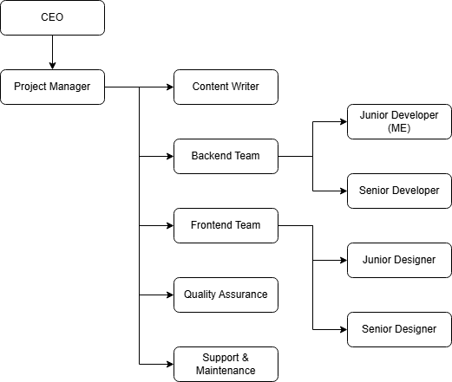

Figure 2.1: Organization Hierarchy

* 1. **Working Domains of Organization**

Blazethemes Pvt. Ltd. primarily operates in the field of **WordPress web development**, offering a range of specialized services to meet the needs of diverse clients. The organization’s key working domains include:

1. **WordPress Theme Development** – Blazethemes specializes in designing and developing custom WordPress themes tailored to the unique requirements of clients, ensuring both functionality and aesthetic appeal.
2. **WordPress Plugin Development** – The company develops custom WordPress plugins to extend website functionality, along with seamless integration of third-party plugins to enhance the website’s performance and features.
3. **Mobile App Development** – Blazethemes creates custom mobile apps for clients with diverse needs and requirements as well.
   1. **Description of Intern Department/Unit**

The Intern Department at Blazethemes Pvt. Ltd. offers aspiring developers and designers hands-on experience in WordPress web development. Interns work alongside experienced professionals in the development and design teams, contributing to live client projects. They gain exposure to custom theme development, plugin integration, and Elementor widget creation while learning industry-standard tools like PHP, JavaScript, and WordPress.

The department emphasizes mentorship and collaboration, allowing interns to enhance both technical and soft skills. Interns participate in all stages of the web development process, from design to deployment, helping them refine their skills and prepare for careers in web development.

Table 2.2: Duration of Internship

|  |  |
| --- | --- |
| **Start Date** | November 5th, 2024 |
| **End Date** | February 5th, 2025 |
| **Mentor** | Mr. Dinesh Maharjan |
| **Position** | Intern |
| **Duration** | 12 Weeks |
| **Working Hours** | 8 hours |
| **Working Days** | 6 days a week |

# **: Background Study and Literature Review**

## **Background Study**

In today’s digital world, **WordPress** has become the go-to platform for building websites, powering over 40% of the internet. Its flexibility and ease of use make it ideal for everything from personal blogs to complex enterprise sites. A key tool in WordPress development is Elementor, a drag-and-drop page builder that enables users to create custom, responsive web pages without needing to write code.

During my internship at Blazethemes Pvt. Ltd., I worked with these technologies to enhance client websites, such as **tthimalaya.com**, and developed custom **Elementor widgets** for the **News Kit Elementor Addons** plugin, aimed at the news and media industry.

During my internship, I faced challenges like balancing custom widget functionality with website performance and ensuring cross-device compatibility. These obstacles provided valuable opportunities to refine my skills in performance optimization, responsive design, and SEO practices. I learned to write efficient code, implement responsive design effectively, and apply SEO strategies to improve site visibility, turning these challenges into key learning experiences.

The need for **customization** and **optimization** in web development is growing. As businesses demand more dynamic, tailored solutions, tools like WordPress and Elementor are at the forefront of this transformation. My internship provided valuable insight into how these technologies are applied in real-world projects to meet client demands for flexibility, performance, and visibility.

## **Literature Review**

(Elementor, 2022) talks about what Elementor is, is it really a must-have tool or is it just smoke and mirrors? It explains about how to install Elementor, its competition, support, ecosystem, etc. But fails to dig deeper in performance and responsive side of this. I found that part to be extremely lacking. It should have dug deeper for the viewers to understand how Elementor will impact their website and its responsiveness.

(Moghul, 2013) this paper explains what WordPress is, its architecture, technologies used and showcases the web portal they created using WordPress. The author expressed that it was a bit hard to understand the installation process and some of its features in the initial stages. They fail to mention about plugins that can help boost the websites performance, SEO, etc. I just wish it talked about their web portals performance, responsiveness, issues they faced while creating the web portal, etc.

(G. Maragatham, 2019) this papers studies on performance analysis for different WordPress and hand code webpages. It touches on factors that make a website load in the minimal amount of time. This research paper classifies the web pages according to their type and analyze what method of webpage is best suitable for the development.

# **: Internship Activities**

## **Roles and Responsibilities**

During my internship at **Blazethemes Pvt. Ltd.**, I was entrusted with various responsibilities related to the development of a custom WordPress theme (Tthimalaya.com) and Elementor widgets for News Kit Elementor Addons. My primary roles included:

* **Custom Theme Development:** I was tasked with coding the custom WordPress theme, ensuring it was optimized, and aligned with the client’s branding.
* **Elementor Widget Development:** I contributed to the creation of custom Elementor widgets, enhancing the functionality and user experience of the plugin.
* **Quality Assurance and Testing:** I conducted regular testing to identify and resolve any bugs or performance issues, ensuring that the website functioned seamlessly across different devices and browsers.
* **Collaboration and Communication:** I worked closely with senior developers, designers, and project managers, participating in team meetings and providing updates on the progress of assigned tasks.

## **Weekly Log**

Table 4.1: Weekly Log

|  |  |
| --- | --- |
| **Duration** | **Tasks / Activities** |
| **1st and 2nd Week** | Small tasks were assigned to me in clickup to get familiar with coding best practices, company standards and assess my level. Some tasks were:   * Admin login and registration Form * CURD Operation * Array and Date functions of PHP and JavaScript |
| **3rd Week** | Create a Gallery Management System   * add gallery images page - user must be able to add multiple images * create gallery page - user must be able to select the images from existing one. * Gallery list page - view all galleries in one page * Integrate lightbox in each image on gallery list page * add masonry layout for gallery images |
| **4th Week** | Create a Tic Tac Toe, using JavaScript   * Ask the email address and full name of two users at the beginning of the game * Store the winner and loser info in database * Tic Tac Toe - develop a game using simple html and JavaScript language * If the same email address plays games later show his/her game history |
| **5th Week** | * Learn to install WordPress * Make it multisite * Download a starter theme, customize, install and activate it * Learn about WordPress * Template Hierarchy (WordPress, Template Hierarchy, n.d.) * Theme Handbook (WordPress, Theme HandBook, n.d.) |
| **6th Week** | * Learn how WordPress handles its files and pages * URL Anatomy (Chi, 2023) * create homepage, archive page and single page for client site |
| **7th Week** | * Learn about meta box from plugin handbook (Wordpress, n.d.) * Make use of ACF Plugin to add metaboxes in client site * Learn about WordPress customizer and add custom customizer options |
| **8th Week** | * Add different menu page in client site dashboard like testimonials, FAQs, reviews, etc. * Quality Assurance (QA) and testing in client site * Study and make a simple block editor theme |
| **9th Week** | * Get familiar with elementor page builder * Learn about elementors editor, editor controls, hooks, scripts and styles, etc. * Create phone call, mailbox, back to top, etc. widgets. |
| **10th Week** | * Study market trends to find out what kind of themes and plugins are popular and are gaining hype. * Study other themes and plugins to gain a better knowledge about our competition and the features they give out. * Create 5 main banner, 3 news list and 3 news grid widgets with different layouts |
| **11th – 12th Week** | * Create 3 news carousel, 4 news filter widgets with different layouts * Learn about licensing, learn about different JS framework and libraries we can use to enhance user experience * Mainly focus on RND |

## **Description of the projects involved during internship**

**Project 1: Website Development –** [tthimalaya.com](https://www.tthimalaya.com/)

**Objective:**

To support the development, customization, and optimization of tthimalaya.com, a trekking and travel agency website aimed at providing detailed itineraries, booking options, and promotional content for trekking in the Himalayas.

**Project Description:**

The main goal was to enhance the visual and functional components of the website to ensure a better user experience, responsive design, and easier content management for non-technical staff.

**My Contributions:**

* Helped implement custom Elementor sections for trekking packages and dynamic itinerary pages
* Optimized web pages for faster load times using caching plugins and media compression
* Ensured responsiveness across mobile and tablet devices
* Worked with the SEO team to implement keyword-focused meta tags and structure content for better indexing

**Outcome:**

The website went live with improved performance and user experience. The updated features made it easier for customers to browse and book treks, and the site saw an increase in visitor engagement.

**Project 2: Custom Elementor Widgets -** [New Kit Elementor Addons](https://wordpress.org/plugins/news-kit-elementor-addons/)

**Objective:**

To develop reusable and customizable Elementor widgets that can be integrated into “News Kit Elementor Addons”, enabling content creators to build visually rich websites without writing code.

**Project Description:**

“News Kit Elementor Addons” is a proprietary plugin created to offer additional functionality and advanced design components for news-oriented websites. The plugin adds a range of custom widgets to the Elementor editor, giving users more control over layout, styling, and content display — particularly for dynamically generated blog or news posts.

**My Contributions:**

* Create different post layout widget and general widgets.
* Implemented controls in the Elementor editor to allow easy customization (e.g., changing text, icons, layout)
* Followed coding standards to ensure compatibility with Elementor updates
* Debugged and tested widgets for responsiveness and cross-browser compatibility

**Outcome:**

The custom widgets were successfully integrated into the company’s plugin library and are now used across various client websites to streamline content creation and design consistency.

## **Tasks / Activities Performed**

I was assigned various tasks during my internship including the tasks of both frontend and backend development. Here is a detailed description of how I completed the tasks assigned to me:

1. **Add Slick Slider**

There are many sections where slick slider, a third JS library has been used in tthimalaya.com for example: - the main banner section, destination section, etc. This JS library initializes a slider that has its own functions and events that we can extend to add out own custom functionalities.



1. **Adding Post meta**

Information about the information itself is called meta. The meta fields are shown in the post edit page where we add content such as post image, categories, tags, heading, excerpt, etc.

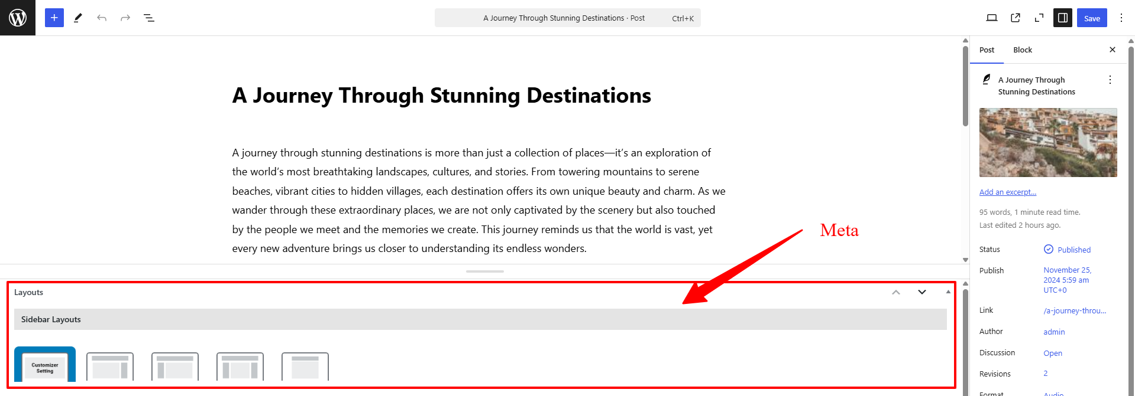

Figure 4.1: Post Meta

1. **Adding custom options in customizer**

WordPress allows developers to add custom features in the customizer for users to dynamically set and add their content. All its doing is calling an AJAX function that performs CURD operations in the background.

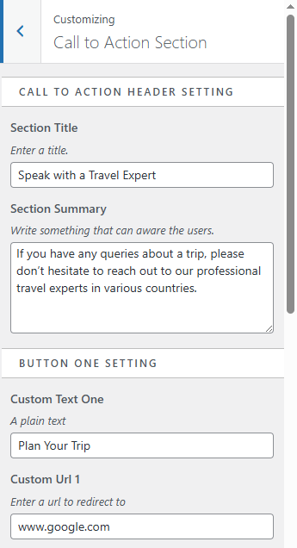

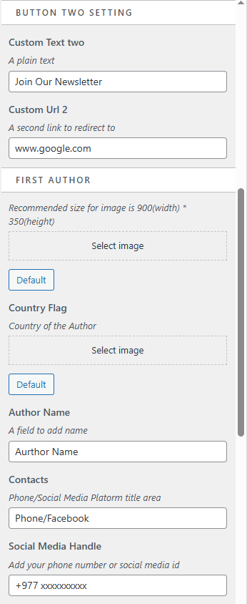

1. **News Timeline Widget**

It is one of the widgets available in News Kit Elementor Addons plugin. It allows the users to select post that they want to display, they can also display via categories, tags and authors. Many design features like margin, padding, font size, font-family, etc. there for the users to play with.

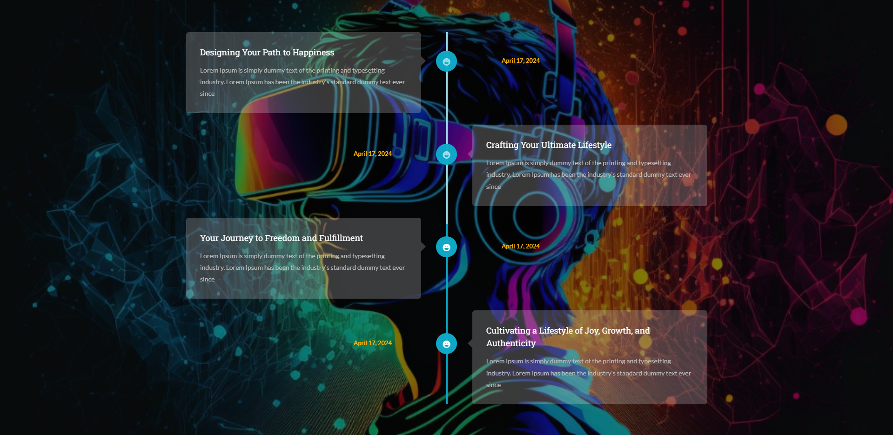

1. **Adding options in custom widgets**

Since News Kit Elementor Addons plugin in built on top of Elementor plugin, it uses various functions, PHP and JS hooks, etc. to build custom widgets and features. There are many different controls that Elementor already uses like text, number, select2, visual choice, etc.

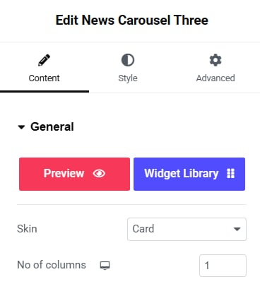

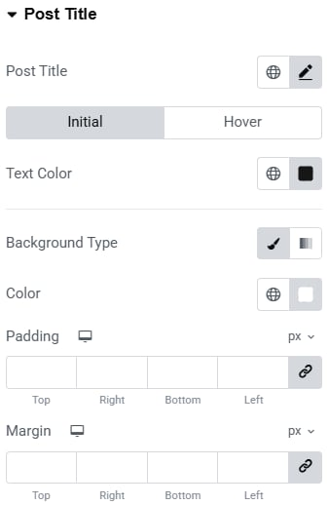

1. **Rendering dynamic contents according to widget settings**

There are many features in a widget. Each one of those features values are stored in database whenever the user changes the control and publishes those changes. Developers have to fetch those values and simply work with it to get the desired output.

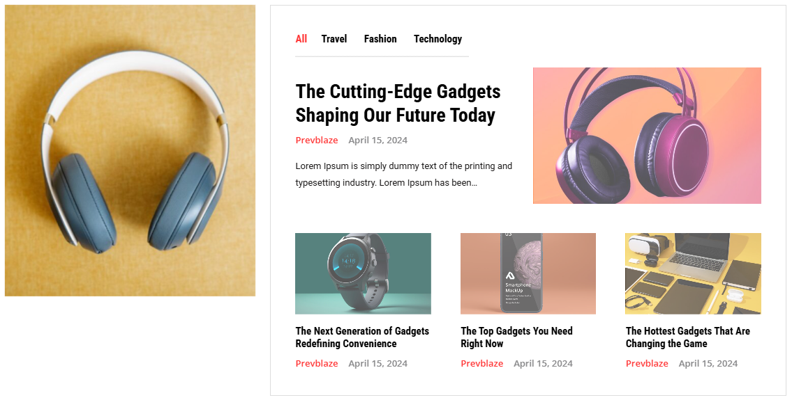

1. **Dynamic Rest API**

Rest API allows developers to fetch various data in the form of JSON. These values are then used to list out all the post titles, categories, tags and authors, etc. Anybody can use this rest API and use it as they like.



# **: Conclusion and Learning Outcomes**

## **Conclusion**

The internship at Blazethemes Pvt. Ltd. provided an invaluable opportunity to gain real-world experience in WordPress development, Elementor customization, and modern web design practices. Throughout the internship period, I was able to apply the theoretical knowledge acquired during my academic studies to practical tasks and professional projects.

Working on [tthimalaya.com](https://www.tthimalaya.com/) allowed me to understand the full website development cycle — from content structuring and responsive design to performance optimization and SEO implementation. It gave me insight into how real businesses operate digitally, especially in the tourism and service sectors.

In parallel, contributing to the [New Kit Elementor Addons](https://wordpress.org/plugins/news-kit-elementor-addons/) plugin development deepened my understanding of plugin architecture, custom widget development, and dynamic content handling using WordPress. It also introduced me to clean coding practices, UI/UX considerations, and teamwork in a collaborative environment.

The internship not only improved my technical competencies but also boosted my confidence, problem-solving ability, and communication skills. It was a valuable experience that has significantly shaped my understanding of professional web development workflows.

## **Learning Outcome**

The internship provided a solid foundation in real-world web development and teamwork. By working on both client and internal projects, I was able to enhance my technical abilities and professional skills. Key takeaways from the experience include:

* Gained practical experience in WordPress and Elementor development
* Learned to build custom Elementor widgets using PHP, HTML, and CSS
* Improved understanding of responsive design and dynamic content handling
* Enhanced problem-solving, time management, and collaboration skills
* Gained insight into plugin development and real-world project workflows

# **References**

(n.d.). Retrieved from Royal Elementor Addons: https://royal-elementor-addons.com/royal-elementor-kit/

Chi, C. (2023, 05 10). *Parts of a URL: A Short Guide*. Retrieved from HubSpot: https://blog.hubspot.com/marketing/parts-url

*Elementor*. (2022, May). Retrieved from Wp Marmite: https://wpmarmite.com/en/wordpress-guides/elementor/

Elementor. (n.d.). *Editor Controls*. Retrieved from Elementor: https://developers.elementor.com/docs/editor-controls/

G. Maragatham, S. A. (2019, July 01). *2018 International Conference on Smart Systems and Inventive Technology (ICSSIT)*. Retrieved from IEEE Explore: https://ieeexplore.ieee.org/document/8748564

Moghul, M. (2013, March). *Creating websites using WordPress – A practical approach*. Retrieved from Research Gate: https://www.researchgate.net/publication/245032512_Creating_websites_using_WordPress_-_A_practical_approach

*Nepal Trekking Experts*. (n.d.). Retrieved from Nepal Trekking Experts: https://nepaltrekkingexperts.com/

Wordpress. (n.d.). *Plugin Handbook*. Retrieved from wordpress.org: https://developer.wordpress.org/plugins/

WordPress. (n.d.). *Template Hierarchy*. Retrieved from WordPress.org: https://developer.wordpress.org/themes/basics/template-hierarchy/

WordPress. (n.d.). *Theme HandBook*. Retrieved from Wordpress.org: https://developer.wordpress.org/themes/

# **Appendices**

